770919401951

АЛЬСЕИТОВА Жанар Джунуспековна,
№1 М.Әуезов атындағы жалпы білім беретін мектебінің ағылшын тілі пәні мұғалімі.
Түркістан облысы, Шардара ауданы

MAKING PLANS

Learning objectives | 5.4.2.1 understand with litle support specific information and detail in short, simple texts on a limited range of general and curricular topics;  5.3.3.1 give an opinion at sentence level on a limited range of general and curricular topics
Lesson objectives | Learnerswill be able to:  - identify the facts and details from the text about Astana  - Express their own opinion about Astana
Level of thinking skills | - Knowledge and comprehension  - Application

Stages/Time | Teachers actions | Students  actions | Assessment | Resources
Beginning  5 min. | The lesson greeting.  The teacher sets the lesson objectives, letting students know what to anticipate from the lesson.  Warm up  Learners are offered to look at the pictures and name the actions. – look at the actions  What do you see in this picture?  What do you think we will learn today?  The teacher shows several pictures to guess the topic.  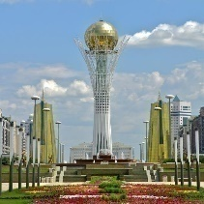  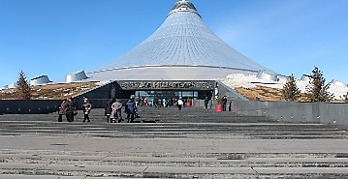  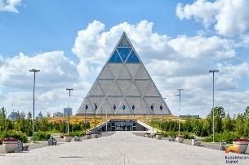 | Greeting  Learners try to guess the topic of the lesson | Oral  Feedback   | А4 paper
Main part  Pre reading task  7 min. | W.  “Answer the question” activity.  Watch the video and answer the question.  - What beautiful places can you see on the video?  - What did you like best about the video? | Students watch the video and give their ideas about the video. | Whole class. Oral  Feedback  Well done  Excellent | https://www.google.com/search?q=one-day+tours+of+astana+video&sca_esv=570067020&sxsrf=AM9HkKkMuA8i22WasRyA9A_wRfHyZym
While reading task  Reading the text  Doing the task  10 min. | - Extensive reading. Scan‘Matching’ activity.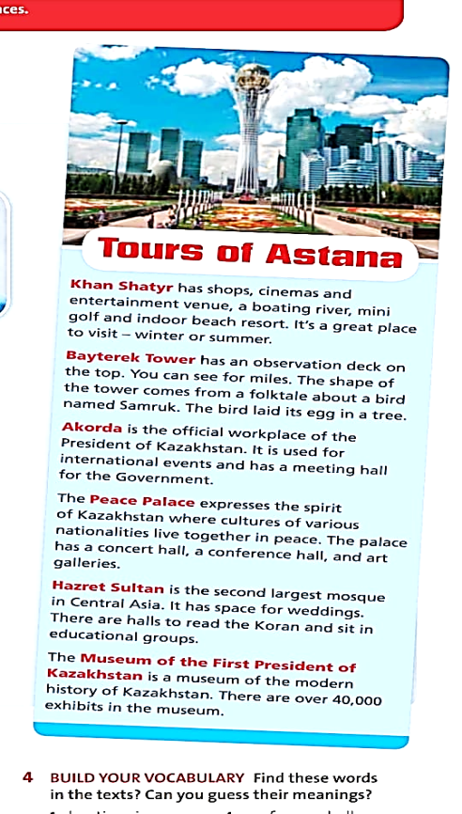  The teacher will give matching task according to the text.  - Khan Shatyr  - Bayterek Tower  - Akorda  - Peace Palace  - Hazret Sultan  - The Museum of the First P Kazakhstan  - It’s a great place to visit – winter or summer  - The palace has a concert hall, a conference hall, and art galleries  - You can see that the shape of the tower is borrowed from a folk tale about a bird  - It has space for weddings. there are halls to read the koran and sit in educational groups.  - The official workplace the President of Kazakhstan  There are over 40,000 exhibits in the museum  Teacher will give A 1 level text and CCQ questions  First of all, I’m going to take you to a very high place. It’s a tower and we are going to go up to the top. It’s over 100 metres high. It’ll be very exciting. Next, we’re going to walk around the city centre. Of course, you must try some Kazakh food so for lunch you are going to eat beshbarmak, a delicious dish with meat and noodles. In the afternoon we are going to visit an entertainment centre shaped like a tent and watch a film. | Descriptors  A learner  - Learners read the text and matching  Differentiation by support:  - Learners read the text.  Differentiation by support:  - Less able learners answer yes or no questions  ‘YES or NO questions’  1 Are they going to a very high place? (Yes)  2. Are they going to eat beshbarmak for lunch? (Yes)  3. Are they going to go to Washington? (NO)  4. Are they going to visit an entertainment centre shaped like a tent and watch a film in the morning? (NO) | Criteria  -Students get one point for every correct answer | English Plus  Grade 5 Student’s Book Ex: 2 p 98 99  A4 paper
After reading  Pair work  - 3 min. | P. “Discussion” activity  Answer the question in pairs:  “What would you do if you had one-day tour to Astana?” | Descriptors  A learner  - make a new dialogues with your classmate.  - Students express their own ideas about day trips around Astana | Criteria  -Use top vocabulary  -Use be going to
Pre speaking task  - 5 min. | W. “What is the answer” activity.  The teacher will show a map of England on the board and ask questions:  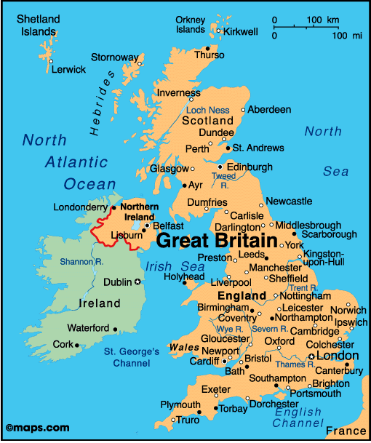  - What country do you see on a map?  - What is capital of the county?  - What kind of sightseeing do you know in England? | Descriptors  A learner  -Answer the questions  - speaking with proper pronunciation | Oral  Feedback  Well done  Excellent | A map
10 min. | Task I VSpeaking task (Pair,Individual works)teacher gives the following questions to organise students will speech, describe a city  ‘Discussion’ activity  T: asks Students to discuss in pairs and choose one city they want to visit.  Give two-three reasons why you choose that city. Justify your opinion by giving reasons and examples.  T:gives the following Qs to organize ss speech  - What’s the city known for?  - What’s the history of that city?  - What’s special in that city?  - Why do you recommend to visit it? | Descriptors  A learner  - Describes a city  - Explains his\her choice  - Uses topic vocabulary and grammar  - Gives 4 sentences with his/her examples  Differentiation by support  Less able student will be given supportive cards with key phrases. They will make up 2 more sentences :  I prefer to go to _______ because there are --------.  I personally enjoy going on holiday with ___________ and ________  because ---------------.  I prefer to go on a trip with __________________ | Criteria  - Uses topical vocabulary accurately  -speaking with proper pronunciation | A4 paper  Card
Conclusion  - 5 min. | “3-2-1” Strategy.  - 3 important information you learned from the lesson today  - 2 aspects that caused difficulties in the lesson today.  - 1 activity that you liked in class today. | 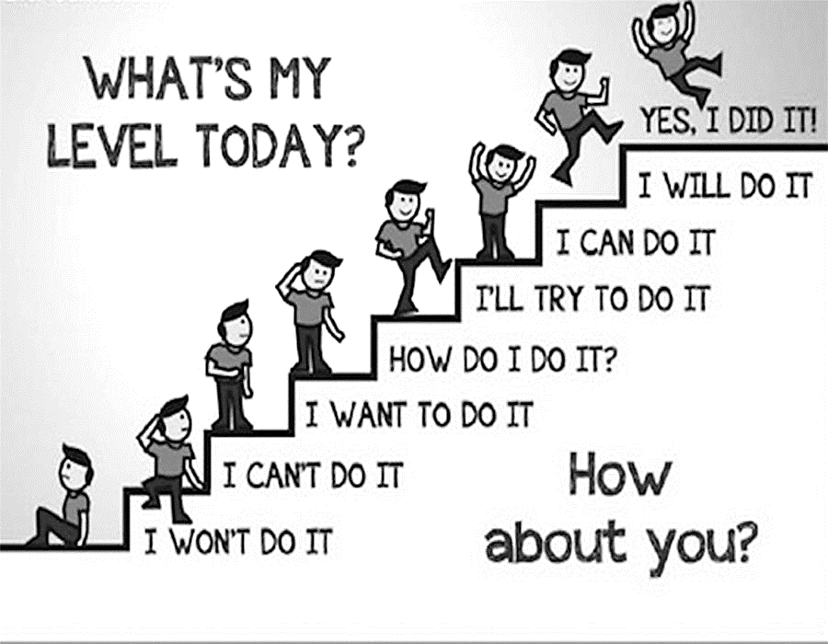 |  | Poster  Picture about “What’s my level today”

